Genuine Buddy Front Rack Installation:

Step 1: Remove front shield. Start by removing the screw in the center of the shield, shown below. (This is where one of the rack bolts will attach later.)

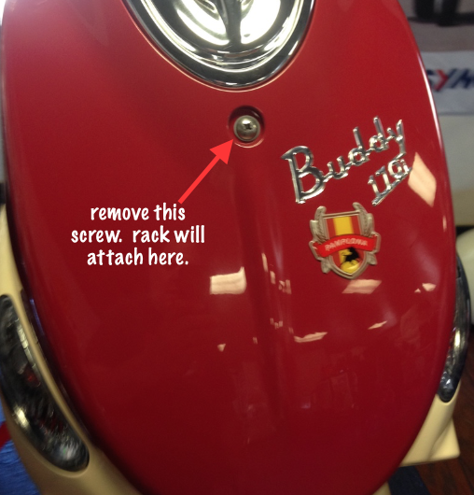

Next remove the two screws in the upper corners of the inside of the legshield. Pictured below.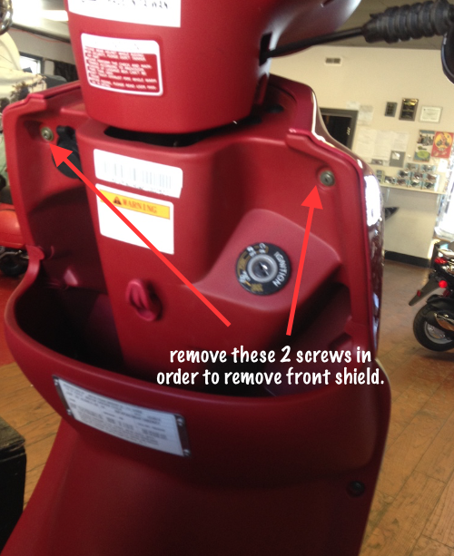


After removing these three screws, the front shield can be removed. Be careful, it is still held in with plastic tabs. You will need to gently persuade it with time, love and tenderness, like Michael Bolton

Step 2: Drill holes in the front shield.

Looking at the front shield from the inside, you can see where the manufacturer left marks for you to drill. You will need two holes here, as the front rack will attach through the front shield at these two points.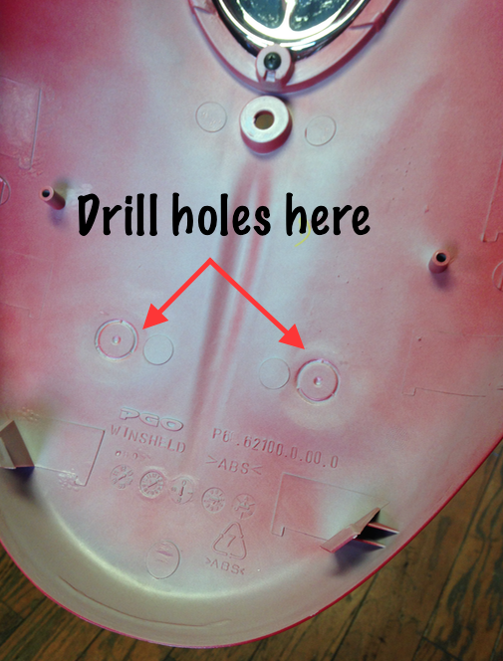

Pictured below, you can see where the rack will bolt onto the frame. 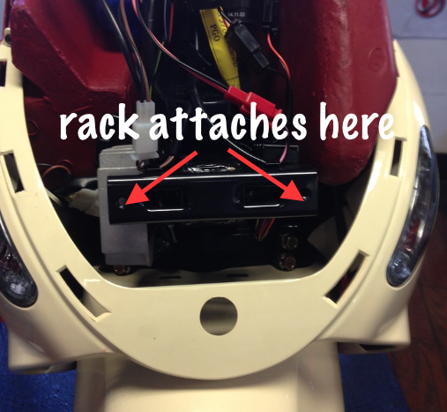
Just re-install your freshly punctured front shield with the two screws you removed in step 1. Then install the front rack through the holes you made, and also through the screw hole that was previously occupied by the first screw you removed in step 1.

